Forum: Security Council
Issue: Non-proliferation/ DPR Korea
Student Officer: Megan Domas
Position: Deputy President of the Security Council

Introduction
The Democratic People’s Republic of Korea (also referred to as DPRK or North Korea) is a secretive and dictatorship nation, born in the midst of the end of World War II, and run by the young leader, Kim Jong-Un. It is situated in Far East Asia, bordering China in the north and sharing a peninsula with: South Korea.
In 2005, DPRK first declared its possession of nuclear weapons to the global community. However, evidence suggests that this discreet nation had been developing and enriching uranium for nearly a decade before their announcement.
Several nations share the belief that DPRK needs to be denuclearized in order to ensure the safety of the global community. One such nation is the United States of America. In 1994, the two nations signed the Agreed Framework which required DPRK to freeze its initial production of plutonium enrichment in return for much-needed aid. However, this agreement failed when North Korea failed to complete its end of the deal. Many such pacts have been made since then, but with similarly disappointing results.
North Korea’s possession of nuclear weapons is seen by the global community as a direct threat to the goals of the Non-proliferation Treaty (hereby referred to as NPT) of global nuclear disarmament. It is also seen as a threat to the stability and peace of the region. The United Nations Security Council has been enlisted to prevent the testing of nuclear weapons as well as the complete abolishment of the nuclear programme in DPRK.

Definition of Key Terms
North Korea
Officially known as the Democratic Republic of Korea, North Korea split from South Korea at the end of WWII along the infamous 38th parallel (one of the most militarized borders in the world). It became a dictatorship state (with communist ideals and practices) under the rule of President Kim Il Sung. His son, Kim Jung l the supreme leader, succeeded him, followed in recent years by his son Kim Jung-Un.
North Korea’s capital is Pyongyang, situated on the western coast of the peninsula. It is a strict and brutal state with an estimated 6 million of its nearly 25 million-strong population living in near poverty and suffering from lack of adequate food and resources. According to Human Rights Watch, nearly 200,000 of those people live in electrical fenced in prison camps. These people (and their families) are usually dubbed ‘enemies of the state’ for their politically-motivated crimes.
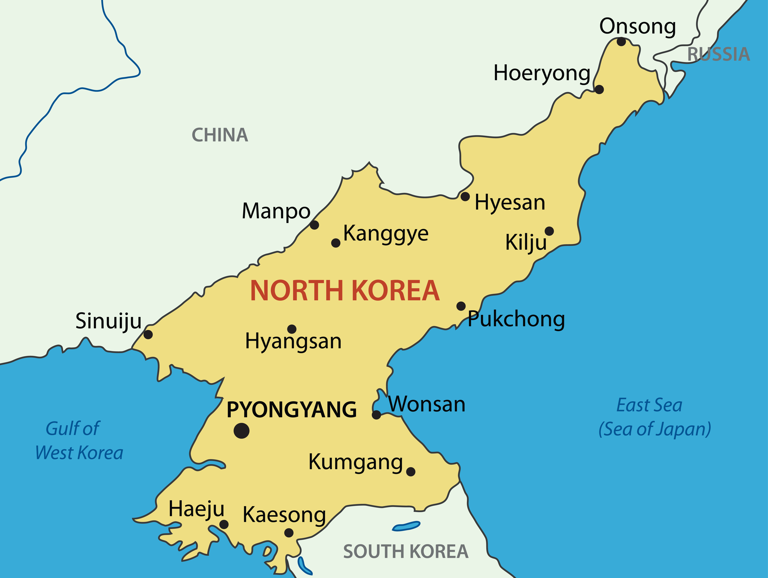
Caption #1: Map of North Korea

Non-proliferation Treaty (NPT)
The NPT is an international treaty that came into force in the 1970s. It calls for the disarmament of nuclear weapons and weapons technology as well as the promotion of peaceful nuclear energy. North Korea ratified the Treaty in 1985 but withdrew from the pact in 2003. A total of 190 countries have signed the Treaty including the 5 permanent members of the Security Council (all who have nuclear weapons). In fact, the only countries with nuclear weapons that have not signed the NPT are India, Pakistan, Israel and North Korea.
Nuclear Proliferation
Nuclear proliferation is the spread of nuclear weapons among all nations. Naturally, many nations believe that an increase in nuclear weapons will increase the likelihood of nuclear warfare. However, it is believed that nuclear proliferation could, at the same time, act as deterrence against future acts of aggression due to mutually assured destruction. The NPT addresses this issue by promoting complete nuclear disarmament over nuclear proliferation.
Nuclear Weapons
Nuclear weapons are explosive devices that through the process of fission produce terrible and destructive forces capable of devastating entire cities and, depending on the size, even regions.

Six-Party Talks
The Six-Party Talks occurred between 2003 and 2009 and are between North Korea, South Korea, United States, China, Japan and Russia. These talks aimed to negotiate a safe and peaceful method of dismantling DPRK’s nuclear programme. In 2007, North Korea agreed to the demands of the other five members in return for humanitarian aid but, rejected the deal just two years later in April 2009 when it attempted to launch a satellite. The talks are no longer standing, despite many pleas for North Korea to re-enter them.
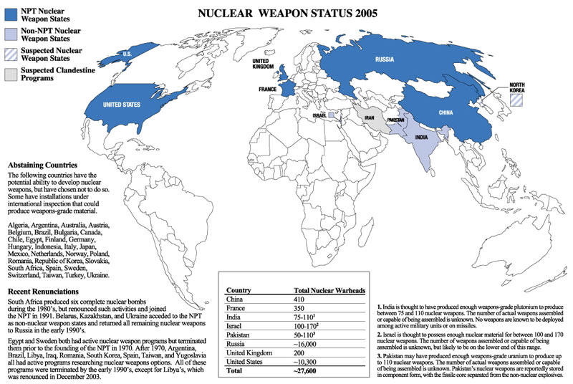

Caption #1: A map showing countries that have both signed the NPT and who have nuclear weapons. One must keep in mind that this map is from 2005, and that in contrast to what the image shows, it is currently widely-believed that North Korea does have an established nuclear programme.
Comprehensive Nuclear-Test-Ban Treaty Organization (CTBTO)
The Comprehensive Nuclear-Test Ban is a treaty adopted by the UN General Assembly in September 1996. This treaty holds great precedence over nuclear disarmament among all nations in the United Nations. It forbids nuclear test explosions for all purposes: both military and civilian. The CTBTO is the organization that has stemmed from this treaty and it operates a worldwide monitoring system. It was established in 1997 and it is based in Vienna, Austria. It is important to realize, however, that CTBT is not a functional treaty because of the non-ratification of eight nations: China, Egypt, India, Iran, Israel, North Korea, Pakistan and the United States.
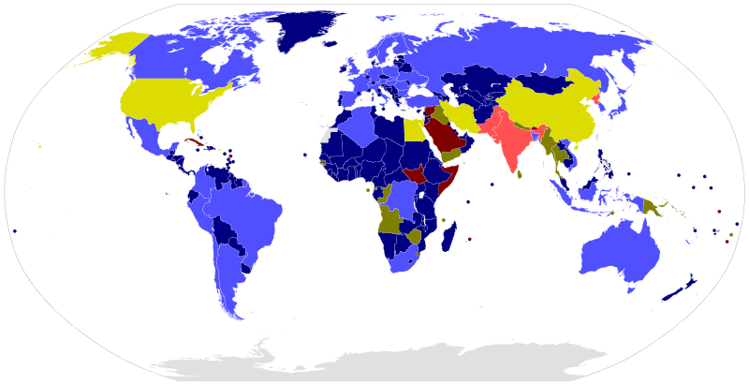

Caption #2: A diagram of the nations that have signed the Comprehensive Nuclear Test-Ban Treaty
Blue: Annex 2 countries that have signed and ratified treaty.  Yellow: Annex 2 countries that have signed treaty  Pink: Annex 2 countries that are non-signatory | Dark Blue: Not Annex 2 countries that have signed and ratified treaty.  Green: Not Annex 2 countries that have signed treaty  Red: Not Annex 2 countries that are non-signatory

1718 Committee
The 1718 Committee was first established after Resolution 1718 was passed by the Security Council in 2006. It is in charge of overseeing the efforts of the North Korean government in complying with the legally-binding decisions set out in the Security Council resolutions. In a recent report in 2012, the committee found that “the Democratic People’s Republic of Korea continues actively to defy the measures in the resolutions” and that the “the resolutions have not caused [North Korea] to halt its banned activities” (Report of the Panel of Experts, 2012)
International Atomic Energy Agency
The International Atomic Energy Agency (or also commonly referred to as the IAEA) was established in 1957 and is a non-governmental agency that is in charge of atomic energy, and more specifically to this case: nuclear energy. It promotes the peaceful methods and usage of nuclear energy, while ensuring that nuclear weapons are prohibited in order to impede possible nuclear warfare.
This organization is independent of the United Nations but is an important contributor to the UN General Assemblies and the Security Council. Its Director General is Yukiya Amino and its annual meeting, the 57th such General Conference IAEA meeting, took place in Vienna in late September 2013. The issues discussed at this meeting included the crisis in Iran, as well as the situation in North Korea.

History
North Korea has a history that is shrouded in secrecy and lies. This military state, had humble beginnings but has grown to be a powerful and aggressive nation. It spends nearly 40% of its GPA on military alone, and the country’s nuclear history is driven as much by its policies as its leaders.

The beginning of a nuclear programme
For North Korea, nuclear capability was the key to the survival of the regime as it deterred attacks from enemies and most importantly, stopped US ‘bullying’. This was important to the hermit state that prioritized economic and political independence as well as high self-reliance in defense. This self-reliance was based on the nation’s policy of ‘juche’- this prioritized economic and diplomatic individualism. Nuclear weapons also gave the relatively poor and unknown DPRK international status and power; it was now a nation that the others needed to be careful around and it was able to maintain negations with other regional and international powers.
It is suspected that North Korea started enriching and researching nuclear warfare as early as the 1960s and 1970s with the help of the then Soviet Union. However, concrete evidence of this was not found until the 1990s when, US satellite photos captured photos of DPRK’s budding nuclear complex.

Nuclear Tests

North Korea has officially had three nuclear tests. The tests in October 2006 and May 2009 were seen by many in the global community as unsuccessful. However, its most recent nuclear test in February 2013 was seen as successful and a potential dangerous threat to the community.

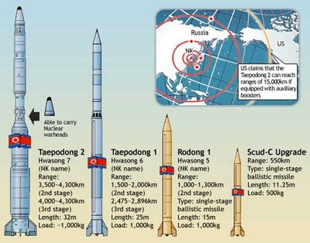

Caption #3: The different nuclear weapons North Korea is believed to have. They are believed to have in between 4 and 8 nuclear weapons in total but they have not been able to successfully test a long-range missile. The Taepodong 2 missile, the most frightening of all of DPRK’s owned nuclear weapons, is believed to have the capabilities of reaching nearly 4000 km.

North Korean Leaders

Kim Jong- il

Kim Jong- IL was born in 1949. He succeeded his father (the founder of the DPRK) Kim Il- Sung in July 1994 to become North Korea’s supreme leader. He was a cold and calculative leader who started enriching plutonium for a nuclear programme. In his opinion, it was a way of establishing national security to protect DPRK from nations such as USA and South Korea; countries he saw as his greatest enemies. Despite his great power and threat, not much was known about him in the international community except for the exceptional, most likely mythical tales, of his bravery and extraordinary talents and skills in sports. He died in December 2011, leaving his power in the hands of one of his younger sons: Kim Jong- un.

Kim Jong- un

Kim Jong- un is Kim Jong- il’s third son. In December 2011, at the young age of 28, he took over power from his father as supreme commander of DPRK. Despite the unexpected change in leadership, it seemed unlikely that North Korea would change its disposition toward nuclear weapons and in fact the young dictator had made his intentions of following in his predecessor’s footsteps clear, by testing out nuclear weapons more frequently in the past few months.

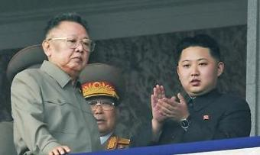

Caption #4: An undated image of Kim Jong- il with his son Kim Jong- un

Key Issues
There are many issues that arise from North Korea’s nuclear capability but the most important is the threat to the stability of the international community that arises from this nation’s possible, powerful nuclear capabilities.

Threat to the Community

North Korea has displayed in the past many unpredictable acts of heated aggression. The worst examples were: the sinking of a South Korean vessel, the bombing at the Olympics held in South Korea and the shelling of a South Korean island. These are only a few events but they highlight the aggressive nature of North Korea, especially to its former enemy: South Korea.

Nuclear weapons would exacerbate the problem because the damage and death count would be devastatingly worse. It also increases the global threat because these weapons are able to reach long distance, depending on the type. The ones that US fear the most are the long-range missiles that can potentially reach as far as the US west coast (namely Hawaii and Alaska). This could potentially lead to a wide-spread nuclear conflict, drawing in powerful nations such as China and Russia (both of whom have nuclear weapons themselves).

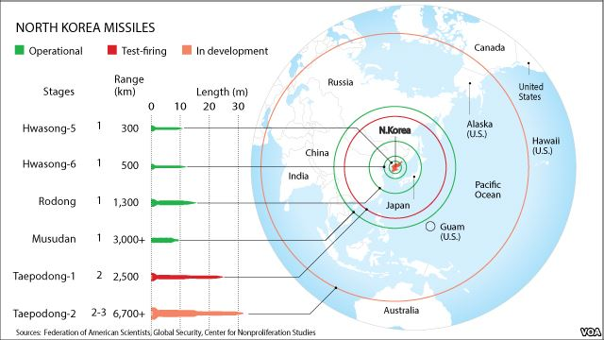

Caption #5: A diagram of North Korea’s believed current nuclear capabilities.

Major Parties Involved and Their Views

United States of America
USA and North Korea have been in ‘mental’ conflict since the Korean War that saw USA supporting South Korea in order to contain the spread of communism in Asia. USA considers the denuclearization of North Korea as one of their most important goals as well as the safety of South Korea from any acts of aggression by the Democratic Republic of North Korea.
Through the years the two have made and fallen out of agreements, and their differences in point of view have created more tension in an already cold relationship. The highest peak in their relationship can be defined in the 1990s when President George Bush Senior removed the last of the nuclear bases of the South Korean peninsula. This led to the Agreed Framework (see introduction) which consequently introduced a positive prospect of denuclearizing North Korea once and for all. However, erratic and inconsiderate actions taken by DPRK, which blatantly ignored the deals made between the two nations, led to a strain in their relationship which has not been remedied even in current times. Later on, when President George W Bush became president, he viewed North Korea as one of the ‘axis of evil’ along with Iran and Iraq.
One must consider, however, other points of view. Some believe that United States of America is actually acting like the ‘bully’ that North Korea deems USA to be. This is because, despite having nuclear capabilities themselves, America wishes to impose denuclearization on other smaller nations through the use of threat (they have in fact threatened to nuke DPRK as early as the 1960s; this threat was especially dangerous when USA had nuclear bases in South Korea) and diplomatic aggression.

South Korea
Despite a volatile history, the two neighbouring nations have seen a steady progress in their relationship in recent months. Although, unification is highly unlikely many Korean citizens favour reconciliation between the former enemies. However, events in the past years have also revealed the two different countries’ fluctuating relationship that has sometimes been so strained that many in the international community believed that conflict between the two would be almost certain. One such example where tension was extremely high was in November 2010 when North Korea was found guilty of sinking a South Korean vessel, drowning 46 South Korean sailors.

China

China has been a key ally of North Korea since Mao took over power in 1949, declaring the People’s Republic of China. They share similar ideologies and systems and both have an implemented Communist regime. During the Korean War, China aided North Korea with as many as 3 million soldiers (this was more out of self-interest and a desire to preserve communism on the peninsula). However, at the end of this conflict, North Korea and China agreed to work together to ensure strong secure and defense lines. Economic-wise North Korea would not survive without China’s indispensable trade. In fact, China contributes to nearly 70% of North Korea’s foreign trade (supporting North Korea with important fuel and food).

Despite their strong relationship, China, similar to USA, Russia, and others in the international community, believes that North Korea should also denuclearize. This is mainly because of North Korea’s looming threat to bomb South Korea; an act of aggression that would draw China into a messy affair that they would rather remain neutral about. It is also a powerful threat (as small as it may be) from a nation that is right on China’s doorstep. In any situation, that would create some level of fear and discomfort, especially among the Chinese civilian population. China’s president Xi Jinping has been quoted as saying “No one should be allowed to throw a region and even the whole world into chaos for selfish gains”. Although, he has never specifically implicated North Korea, it does demonstrate China’s increasingly colder response towards North Korea’s demands to continue developing and testing nuclear weapons.

Russia
North Korea’s biggest neighbor along the Tumen River, Russia is a close ally of the communist nation ever since the end of WWII. The two fought on the same sides against America and South Korea in the Korean War (1950-1953), ultimately establishing an independent state from its Southern counterparts along the 38th parallel. They maintained extremely good relationship during the period of the Cold War, but this relationship has grown weaker after the breakdown of the Union of Soviet Social Republics (USSR).
The two share exceptionally strong economic ties. Russia has invested in an expensive and wide-spread system of oil and gas pipelines that extend to the more isolated eastern regions of Russia- making these lines extremely critical to Russia’s economy. Despite this, public opinion in Russia on the North Koreans is at an all-time low. Nearly 60% believe that North Korea should not have nuclear capabilities because it poses a serious threat to regions in the vicinity of DPRK. The Russian government, are also more wary about the manufacturing of the weapons, claiming that the method in which they are made is old-fashioned and more likely to implode, and become a catastrophic man-made disaster affecting not only North Korea but China, South Korea and ultimately Russia.

Timeline of Relevant Resolutions, Treaties and Events
Date | Description of event
1994 | USA and North Korea sign the Agreed Framework
2005 | North Korea officially declares possession of nuclear weapons
October 14th 2006 | Resolution 1718 passed. It was an immediate response to DPRK’s October 9th 2006 nuclear test.
June 12th 2009 | Resolution 1874 passed. This resolution was a response to an underground nuclear test on May 25th 2009.
December 12th 2012 | North Korea tests a satellite launch which is in violation of Security Council resolutions 1718 (2006) and 1874 (2009)
January 22nd 2013 | Resolution 2087 passes in the Security Council
March 7th 2013 | United Nations Security Council passes another resolution (Resolution 2094) in response to a North Korea nuclear test in February 2013.

UN Involvement, Relevant Resolutions, Treaties and Events
UN has been greatly involved in this issue seeking to provide a solution through the Security Council as to the growing situation of non-proliferation in North Korea.
- United Nations Security Council Resolution 1718, October 2006
- United Nations Security Council Resolution 1874, 2009
- United Nations Security Council Resolution 2087, January 2013
- United Nations Security Council Resolution 2094, March2013

Evaluation of Previous Attempts to Resolve the Issue
So far, the Security Council has passed five resolutions (2006, 2009 and 2012 and two in 2013) that address this situation directly. These resolutions are as long and complicated as the situation at hand but the problem lies in the fact that these resolutions are useless when the addressed party does not comply (as is the case in this situation in North Korea). These resolutions ban North Korea from launching satellites and testing nuclear weapons. They also, more specifically, called upon North Korea to rejoin the NPT and the Six-Party Talks. The resolutions also establish damaging sanctions on the nation (one of the most important banned items are weapons excluding small arms) in an attempt to starve them off the resources they need in order to continue developing more nuclear weapons. Although, it has slowed down DPRK’s nuclear progress, these attempts have failed to fully abolish North Korea’s nuclear programme.

Possible Solutions
It is evident that North Korea lacks the will to denuclearize and abolish its nuclear weapons. As such, the United Nations Security Council faces a tricky situation of enforcing both its rules and the previous Security Council resolutions. These resolutions are strong frameworks and if they were able to be implemented properly, they eradicate the problem of North Korean nuclear capabilities. However, force is not an option and thus aggressive diplomacy and open talks between all nations involved is important. More so, diplomatic pressure and further economic and military sanctions on North Korea will force the dictatorship nation to agree to the guidelines set out by the resolutions.

Bibliography
"Comprehensive Nuclear-Test-Ban Treaty." Wikipedia. Wikimedia Foundation, 08 Dec. 2013. Web. 21 Aug. 2013.
http://en.wikipedia.org/wiki/Comprehensive_Nuclear-Test-Ban_Treaty

Nuclear Proliferation." Wikipedia. Wikimedia Foundation, 25 July 2013. Web. 27 July 2013. https://en.wikipedia.org/wiki/Nuclear_proliferation

"UNODA - Non-Proliferation of Nuclear Weapons (NPT)." UN News Center. UN, n.d. Web. 29 July 2013.
http://www.un.org/disarmament/WMD/Nuclear/NPT.shtml

"Chronology of U.S.-North Korean Nuclear and Missile Diplomacy." Arms Control Association. Arms Control Association, Apr. 2013. Web. 16 July 2013. http://www.armscontrol.org/factsheets/dprkchron
"Treaty on the Non-Proliferation of Nuclear Weapons." Wikipedia. Wikimedia Foundation, 14 July 2013. Web. 16 July 2013.

"North Korea's Reviving Economy Defies Sanctions." Oxford Analytica. N.p., 2013. Web. 14 July 2013.
"UN Security Council Resolutions on North Korea." Arms Control Association. Arms Control Association, 2012. Web. 17 Aug. 2013.
http://www.armscontrol.org/factsheets/UN-Security-Council-Resolutions-on-North-Korea

"LILITH NEWS." : North Korea to Launch Missile Satellite into Orbit. N.p., n.d. Web. 17 Aug. 2013. http://www.lilithnews.com/2009/03/north-korea-to-launch-missile-satellite.html

"North Korea." Center for Arms Control. N.p., n.d. Web. 18 Aug. 2013. http://armscontrolcenter.org/issues/northkorea/

"Fact Sheet: North Korea's Nuclear and Ballistic Missile Programs." Center for Arms Control. N.p., n.d. Web. 18 Aug. 2013. http://armscontrolcenter.org/issues/northkorea/articles/fact_sheet_north_korea_nuclear_and_missile_programs/

Clark, Ted. "How Will the World React to a Nuclear North Korea?" NPR. NPR, n.d. Web. 19 Aug. 2013.
http://www.npr.org/templates/story/story.php?storyId=6247694

Malkin, Bonnie. "Xi-Obama Summit: US and China Agree North Korea Must Give up Nuclear Weapons." The Telegraph. Telegraph Media Group Limited, 9 June 2013. Web. http://www.telegraph.co.uk/news/worldnews/northamerica/usa/10108442/Xi-Obama-summit-US-and-China-agree-North-Korea-must-give-up-nuclear-weapons.html

North Korea Tension 'prompts US Missile Test Delay'" European Daily. N.p., 7 Apr. 2013. Web. 12 Sept. 2013.
http://europeandaily.com/abroad/2013/04/07/north-korea-tension-prompts-us-missile-test-delay

"International Atomic Energy Agency (IAEA)IAEA Home." International Atomic Energy Agency (IAEA). IAEA, n.d. Web. 14 Sept. 2013.
http://www.iaea.org/

"International Atomic Energy Agency." Wikipedia. Wikimedia Foundation, 09 Feb. 2013. Web. 14 Sept. 2013.
http://en.wikipedia.org/wiki/International_Atomic_Energy_Agency

"20 Facts about North Korea." USA Today. Gannett, 13 Apr. 2013. Web. 14 Sept. 2013. http://www.usatoday.com/story/news/world/2013/04/13/north-korea-factoids/2078831/

McCormack, Gavan. "Japan as a Nuclear State :: JapanFocus." Japan as a Nuclear State :: JapanFocus. The Asia-Pacific Journal, n.d. Web. 14 Sept. 2013.
http://www.japanfocus.org/-Gavan-McCormack/2488

Faure, Andrew. "I Can't Believe I'm Saying This: USA SHOULD Declare War! | Andrew Faure's Empower Network Blog." Andrew Faures Empower Network Blog. N.p., 25 Jan. 2013. Web. 14 Sept. 2013.
http://www.empowernetwork.com/scoodor/blog/the-usa-should-declare-war/

Parry, Richard L. "Kim Jong Il ‘doubted’ Naming Youngest Son as Successor." The Times of London. The Times, 14 Sept. 2013. Web. 14 Sept. 2013. http://www.thetimes.co.uk/tto/news/world/asia/article2891644.ece

"North Korea–Russia Relations." Wikipedia. Wikimedia Foundation, 09 Oct. 2013. Web. 16 Sept. 2013.
http://en.wikipedia.org/wiki/North_Korea–Russia_relations

"China–North Korea Relations." Wikipedia. Wikimedia Foundation, 09 Sept. 2013. Web. 16 Sept. 2013.
http://en.wikipedia.org/wiki/China–North_Korea_relations

